

NATIONAL UNIVERSITY OF TECHNOLOGY
(Department of Computer Science)
CS161– Database Systems
Instructor: Noushin Saba
Name: Bisma Fatima
Roll no: f24605036

LAB TASK 02

IN LAB TASK
Task 1
For the given database Sales perform the following:
• List All Products in the Database
STEPS
1. Open the Access database and navigate to the Query Design view.
2. Select "Query" > "New Query" and choose "Design View".
3. In the Query Designer, select the "Product" table and add all fields (*) to the query.
4. Run the query by clicking the "Run" button or pressing F5.

o Use a Select Query to retrieve all records from the Product table.
DESIGN VIEW
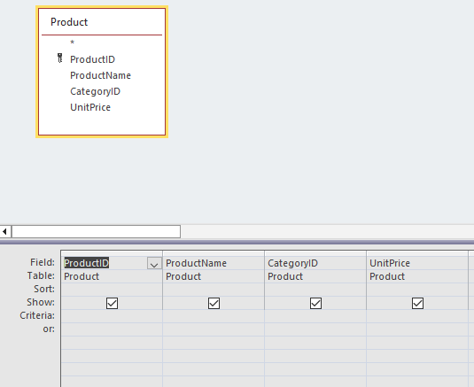

o Display Product ID, Name, Price, and Category ID.
DATASHEET VIEW
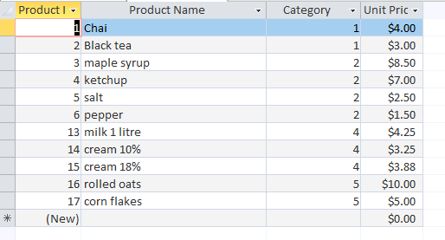

• List All Stores in a Specific Province
o Create a Parameter Query to retrieve stores based on user input.
STEPS
1. Create a new query in Access and select "Query Design" view.
2. Add the "Stores" table to the query and select the fields to display.
3. In the "Criteria" row, enter [Enter Province] in the Province field to create a parameter prompt.
4. Run the query and enter the desired province when prompted to retrieve the list of stores.

DESIGN VIEW
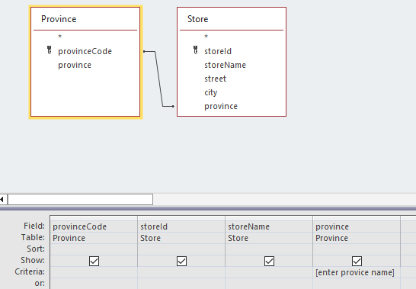
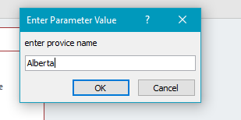
o Display Store ID, Store Name, and Province Name from the Store and Province tables.
DATASHEE VIEW
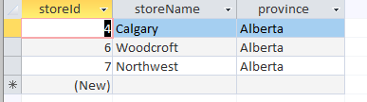

• Sort Products by Price in Descending Order
STEPS
1. Open the Product table in Access.
2. Click on the "Price" field header to select it.
3. Go to the "Home" tab and click on the "Sort & Filter" button.
4. Select "Sort Descending" to sort the products by price in descending order.

o Modify the Product query to display products in descending order of price.
DESIGN VIEW
DATASHEET VIEW
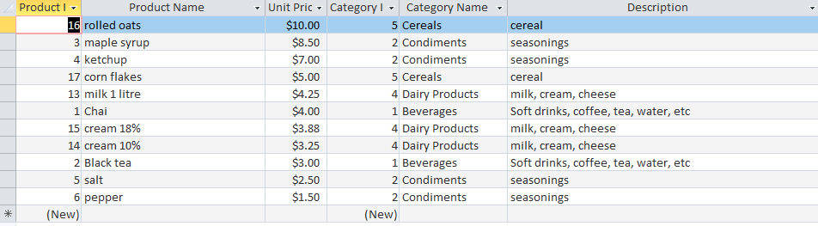

o Filter and Display Only "Beverages" Products
DESIGN VIEW
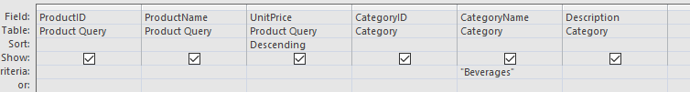
DATASHEET VIEW
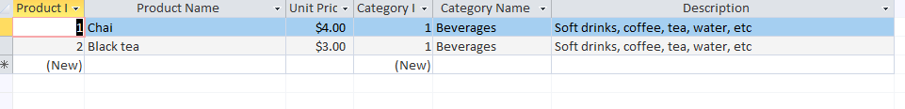

• Retrieve all products where Category Name = "Beverages".
STEPS
1. Open the Query Design view in Access.
2. Add the "Products" table and the "Categories" table to the query.
3. Create a join between the two tables on the "CategoryID" field.
4. In the "Criteria" row, enter "Beverages" in the CategoryName field to filter the results.
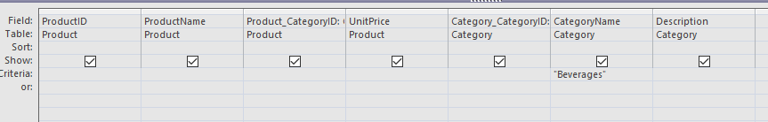
o Find Products with a Price Between $7 and $10
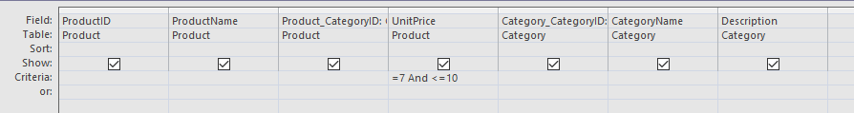
o Use a Between condition to filter products.
DATASHEET VIEW
DESIGN VIEW
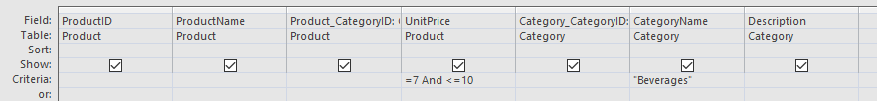

• Find the Total Sales Amount for Each Store
STEPS
1. Create a new query in Access and add the "Sales" and "Stores" tables.
2. Create a join between the two tables on the "StoreID" field.
3. Add the "SalesAmount" field to the query and set its aggregate function to "Sum".
4. Group the query by the "StoreName" field to display the total sales amount for each store.

o Create a Totals Query to sum the SalesAmount grouped by Store ID.
DESIGN VIEW
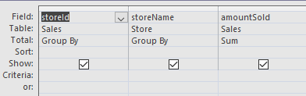
DATASHEET VIEW
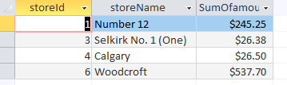

• Find the Average Price of Products in Each Category
STEPS
1. Create a new query in Access and add the "Products" and "Categories" tables.
2. Create a join between the two tables on the "CategoryID" field.
3. Add the "Price" field to the query and set its aggregate function to "Avg".
4. Group the query by the "CategoryName" field to display the average price of products in each category.

o Use the AVG () function to calculate the average product price per category.
DESIGN VIEW
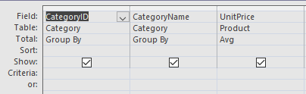

DATASHEET VIEW

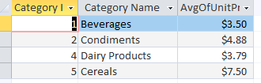

• Count the Number of Products in Each Category
STEPS
1. Create a new query in Access and add the "Products" and "Categories" tables.
2. Create a join between the two tables on the "CategoryID" field.
3. Add the "ProductID" field to the query and set its aggregate function to "Count".
4. Group the query by the "CategoryName" field to display the number of products in each category.

O Use the COUNT () function to count products per category.
DESIGN VIEW
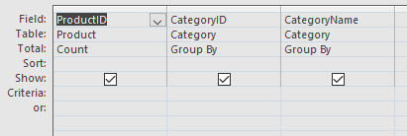

DATASHEET VIEW
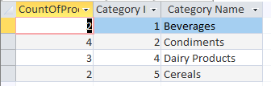
Task 2
• Update Query: Increase Product Prices by 10%
o Update the Price field by multiplying it by 1.10.
STEPS
1. Create a new query in Access and select "Update Query" from the Query Type group.
2. Add the "Products" table to the query.
3. In the "Update To" row, enter [Price] * 1.10 in the Price field.
4. Click "Run" to execute the update query and increase product prices by 10%.

DESIGN VIEW
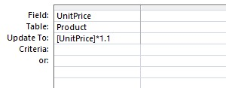

DATASHEET VIEW
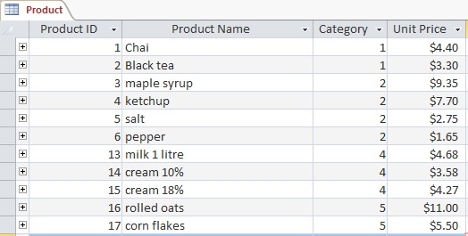

• Append Query: Add New Products from an External Source
o Append new products from NewProducts to the Product table.
STEPS
1. Create a new query in Access and select "Append Query" from the Query Type group.
2. Add the "NewProducts" table (from the external source) to the query.
3. In the "Append To" row, select the "Products" table.
4. Map the fields from "NewProducts" to the corresponding fields in "Products".
5. Click "Run" to execute the append query and add the new products to the Product table.
DESIGN VIEW NEWPRODUCTS TABLE
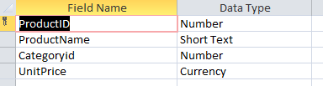
DATASHEET VIEW NEWPRODUCTS TABLE
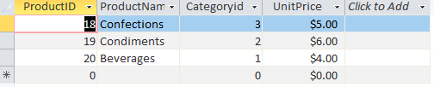

DESIGN VIEW APPEND
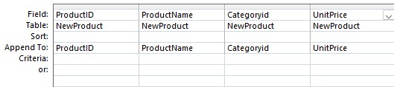

DATASHEET VIEW APPEND
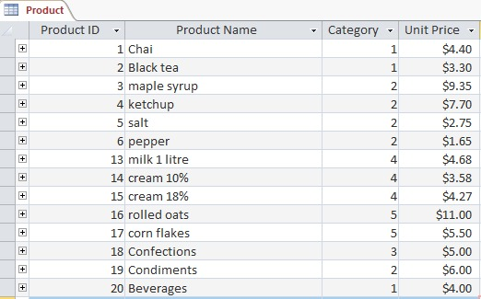

• Delete Query: Remove Products with No Sales Records
o Delete products that do not exist in the Sales table.
STEPS
1. Create a new query in Access and select "Delete Query" from the Query Type group.
2. Add the "Products" table to the query.
3. In the "Criteria" row, enter Is Null in the SalesID field (or the field that links to the Sales table).
4. Alternatively, you can use a subquery: NOT EXISTS (SELECT * FROM Sales WHERE Sales.ProductID = Products.ProductID).
5. Click "Run" to execute the delete query and remove products with no sales records.
DESIGN VIEW
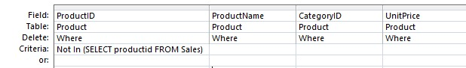

DATASHEET VIEW
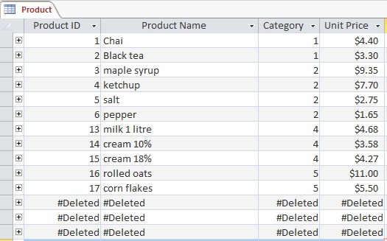

• Make-Table Query: Create a Backup of the Product Table
o Save a copy of the Product table as Product_Backup.
STEPS
1. Create a new query in Access and select "Make-Table Query" from the Query Type group.
2. Add the "Products" table to the query.
3. In the "Table" field, enter Product_Backup as the name for the new table.
4. Select all fields (*) from the "Products" table to include in the backup.
5. Click "Run" to execute the make-table query and create a backup of the Product table.

DESIGN VIEW
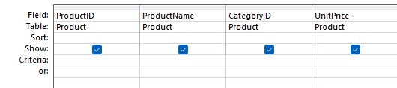

DATASHEET VIEW
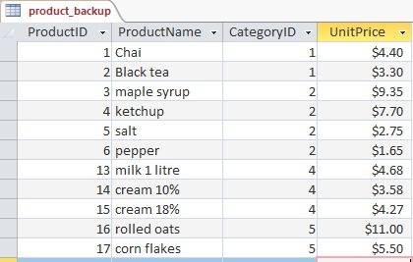

POST LAB TASK
Task 1
List All Products That Have Been Sold in More Than Three Different Stores.
STEPS
1. Click on the "Totals" button (Σ) in the toolbar to enable grouping.
2. In the Total row:
• Set ProductID to Group By.
• Set StoreID to Count.
3. In the Criteria row under StoreID.
4. Run the query by clicking the Run (!) button.

DESIGN VIEW
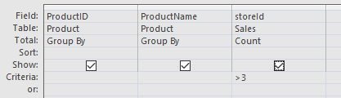

DATASHEET VIEW
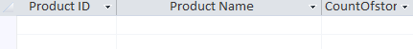

Task 2
Calculates the total sales amount for each store by summing up the SalesAmount field. Display the Store Name along with the Total Sales Amount.
STEPS
1. Add the table containing sales data.
2. Drag the following fields into the query grid:
• StoreName
• SalesAmount
3. Click the "Totals" (Σ) button.
4. In the Total row:
• Set StoreName to Group By.
• Set SalesAmount to Sum.
DESIGN VIEW
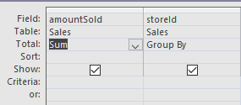

DATASHEET VIEW
